mehsiemens.de/traffic
3rd Party Controllers Interface With SmartGuard
Conception Requirements
Version 0.1

Table of Contents
1. Introduction 6
2. Limitations (Outline) 7
3. System Architecture 8
4. Overview of OCIT-C object types 10

Version

Version | Date | Modifications* |  | Editor
V 0.1 | 2015-09-28 | Creation |  | Pedro S.
*c=change/w=review/r=release

Abbreviations and Description

Abbreviation | Comment
GSM | Global System for Mobile Communications
OCIT | Open Communication Interface for Road Traffic Control Systems
APN | Access Point Name
VPN | Virtual Private Network

References

No. | Document | Content | Where to find?
1 | OCIT-C | Specification | http://www.ocit.org/OCIT-C.htm
2 | Sitraffic smartGuard Brochure | Sitraffic smartGuard System Description and Specifications | http://www.mobility.siemens.com/mobility/global/SiteCollectionDocuments/en/road-solutions/urban/traffic-control-center/sitraffic-smart-guard-en.pdf

Introduction
Sitraffic smartGuard is a system that allows full access to the new Sitraffic sX traffic controller with convenient functions for ease of handling and overview as well as a graphical user interface that helps the user easily locates the required information.
Older controllers cannot connect with this system because they lack the necessary communication protocols. We are developing a solution of hardware and software that would allow these controllers to be represented in smartGuard, though with limited functionality.
This document describes the hardware and software adaptations required by both systems to be able to communicate with each other.

Limitations (Outline)
This document is meant to explain the technical aspects of the solution for the specific scenario of connecting a traffic controller to smartGuard. Although it's possible to adapt the same concept and architecture to work with more types of equipment, if they provide similar functionality as the equipment that is already supported by smartGuard.

System Architecture
Considering the current system in place, smartGuard, along with its features that allow a high level of control and customization over Siemens controllers, a solution was developed to provide similar functionality to other third party controllers.
The developed electrical board opens the possibility for two way communication from the controller to smartGuard using a Siemens supported communication protocol.
The hardware is directly connected into the controller and translates the electrical signals into messages to be sent by an APN network (IP) to the converter.
The data will be stored in the converter server, a Linux based system running a costume OCIT server java application. The data is organized using an already existent data type (IntersectionStatus). The converter is built to communicate to a OCIT client java application that is used by smartGuard to retrieve the information requested by the user.
To handle the communications the electrical board will have an integrated MC55i modem. The board will have full control of the modem, this means it will send commands and read the feedback but also there is the need to have a more passive and higher level of control. This means the modem's power source will pass through the board, giving the ability to shut it down if necessary.
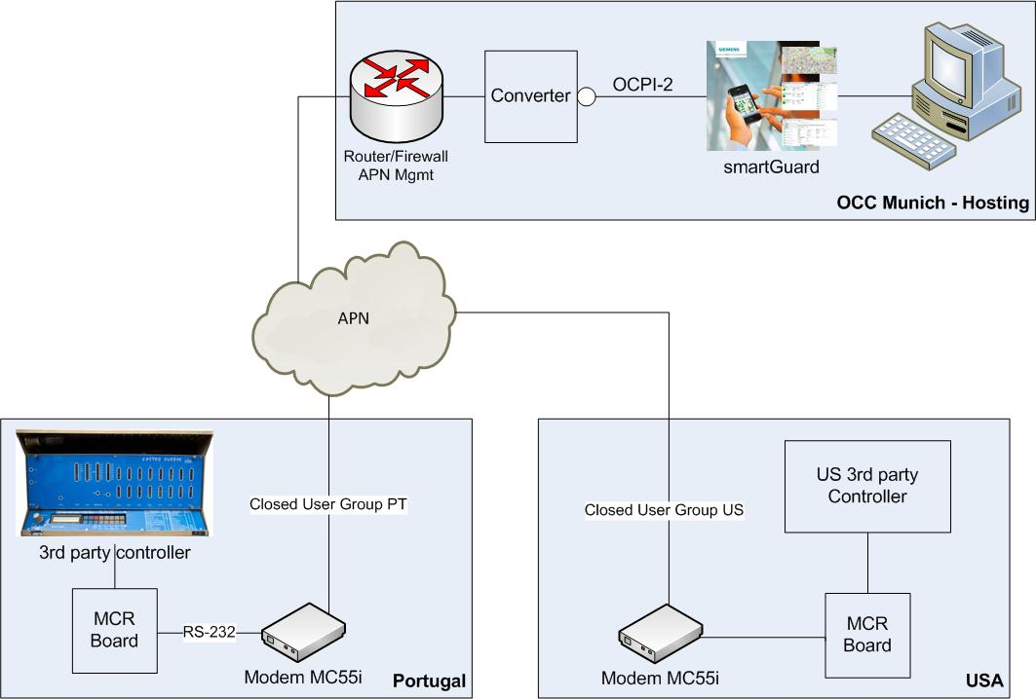

Overview of OCIT-C object types

